**Lab 09c - Implement Azure Kubernetes Service**

**Student lab manual**

**Lab scenario**

Contoso has a number of multi-tier applications that are not suitable to run by using Azure Container Instances. In order to determine whether they can be run as containerized workloads, you want to evaluate using Kubernetes as the container orchestrator. To further minimize management overhead, you want to test Azure Kubernetes Service, including its simplified deployment experience and scaling capabilities.

**Objectives**

In this lab, you will:

* Task 1: Register the Microsoft.Kubernetes and Microsoft.KubernetesConfiguration resource providers.
* Task 2: Deploy an Azure Kubernetes Service cluster
* Task 3: Deploy pods into the Azure Kubernetes Service cluster
* Task 4: Scale containerized workloads in the Azure Kubernetes service cluster

**Estimated timing: 40 minutes**

**Architecture diagram**

[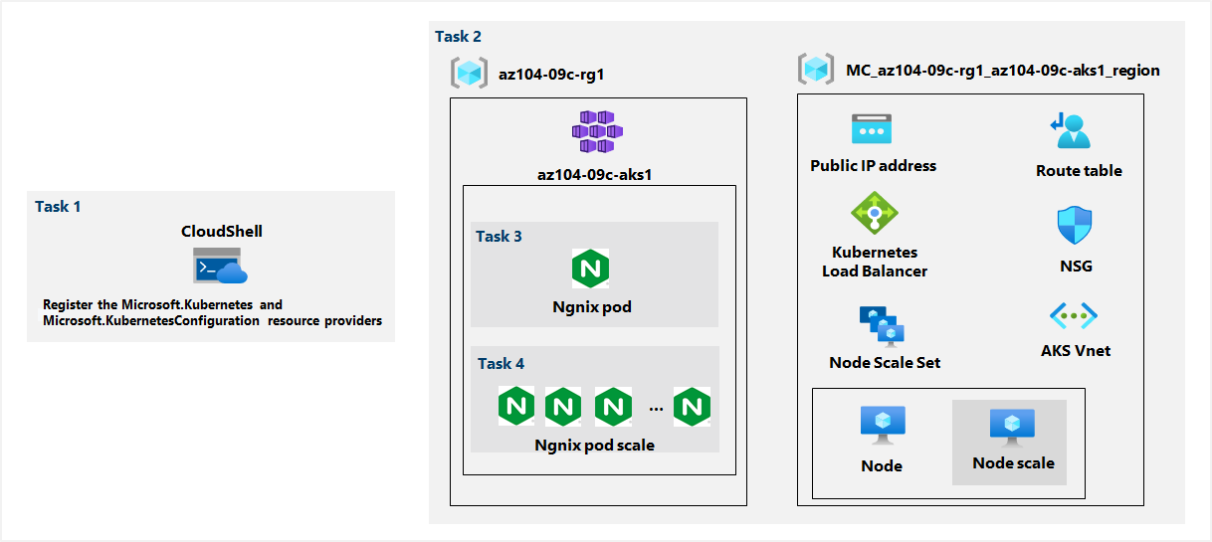](https://github.com/MicrosoftLearning/AZ-104-MicrosoftAzureAdministrator/blob/master/Instructions/media/lab09c.png)

**Instructions**

**Exercise 1**

**Task 1: Register the Microsoft.Kubernetes and Microsoft.KubernetesConfiguration resource providers.**

In this task, you will register resource providers necessary to deploy an Azure Kubernetes Services cluster.

1. Sign in to the [Azure portal](https://portal.azure.com/).

1. In the Azure portal, open the **Azure Cloud Shell** by clicking on the icon in the top right of the Azure Portal.

1. If prompted to select either **Bash** or **PowerShell**, select **PowerShell**.

**Note**: If this is the first time you are starting **Cloud Shell** and you are presented with the **You have no storage mounted** message, select the subscription you are using in this lab, and click **Create storage**.

1. From the Cloud Shell pane, run the following to register the Microsoft.Kubernetes and Microsoft.KubernetesConfiguration resource providers.

Register-AzResourceProvider -ProviderNamespace Microsoft.Kubernetes

Register-AzResourceProvider -ProviderNamespace Microsoft.KubernetesConfiguration

1. Close the Cloud Shell pane.

**Task 2: Deploy an Azure Kubernetes Service cluster**

In this task, you will deploy an Azure Kubernetes Services cluster by using the Azure portal.

1. In the Azure portal, search for locate **Kubernetes services** and then, on the **Kubernetes services** blade, click **+ Create**, and then click **+ Create a Kubernetes cluster**.

1. On the **Basics** tab of the **Create Kubernetes cluster** blade, specify the following settings (leave others with their default values):

| **Setting** | **Value** |
| --- | --- |
| Subscription | the name of the Azure subscription you are using in this lab |
| Resource group | the name of a new resource group **az104-09c-rg1** |
| Kubernetes cluster name | **az104-9c-aks1** |
| Region | **West Europe** |
| Availability zones | **None** (uncheck all boxes) |
| Kubernetes version | accept the default |
| Node size | accept the default |
| Node count | **1-2** |

1. Click **Next: Node Pools >** and, on the **Node Pools** tab of the **Create Kubernetes cluster** blade, specify the following settings (leave others with their default values):

| **Setting** | **Value** |
| --- | --- |
| Enable virtual nodes | **Disabled** (default) |
| Enable virtual machine scale sets | **Enabled** (default) |

1. Click **Next: Authentication >** and, on the **Authentication** tab of the **Create Kubernetes cluster** blade, specify the following settings (leave others with their default values):

| **Setting** | **Value** |
| --- | --- |
| Authentication method | **System-assigned managed identity** (default) |
| Role-based access control (RBAC) | **Enabled** |

1. Click **Next: Networking >** and, on the **Networking** tab of the **Create Kubernetes cluster** blade, specify the following settings (leave others with their default values):

| **Setting** | **Value** |
| --- | --- |
| Network configuration | **kubenet** |
| DNS name prefix | any valid, globally unique DNS host name |

1. Click **Next: Integrations >**, on the **Integrations** tab of the **Create Kubernetes cluster** blade, set **Container monitoring** to **Disabled**
2. Click **Next: Advanced**, set the “infrastructure resource group” to Tajamar and click **Review + create**, ensure that the validation passed and click Create.

**Note**: Wait for the deployment to complete. This should take about 10 minutes.

**Task 3: Deploy pods into the Azure Kubernetes Service cluster**

In this task, you will deploy a pod into the Azure Kubernetes Service cluster.

1. On the deployment blade, click the **Go to resource** link.

1. On the **az104-9c-aks1** Kubernetes service blade, in the **Settings** section, click **Node pools**.

1. On the **az104-9c-aks1 - Node pools** blade, verify that the cluster consists of a single pool with one node.

1. In the Azure portal, open the **Azure Cloud Shell** by clicking on the icon in the top right of the Azure Portal.

1. Switch the **Azure Cloud Shell** to **Bash** (black background).

1. From the Cloud Shell pane, run the following to retrieve the credentials to access the AKS cluster:

RESOURCE_GROUP='az104-09c-rg1'

AKS_CLUSTER='az104-9c-aks1'

az aks get-credentials --resource-group $RESOURCE_GROUP --name $AKS_CLUSTER

COMO VEMOS A CONTINUACIÓN NOS HA CREADO UN .KUBE QUE CONTIENE LAS CREDENCIALES

1. From the **Cloud Shell** pane, run the following to verify connectivity to the AKS cluster:

kubectl get nodes

1. In the **Cloud Shell** pane, review the output and verify that the one node which the cluster consists of at this point is reporting the **Ready** status.

1. From the **Cloud Shell** pane, run the following to deploy the **nginx** image from the Docker Hub:

kubectl create deployment nginx-deployment --image=nginx

1. From the **Cloud Shell** pane, run the following to verify that a Kubernetes pod has been created:

kubectl get pods

1. From the **Cloud Shell** pane, run the following to identify the state of the deployment:

kubectl get deployment

1. From the **Cloud Shell** pane, run the following to make the pod available from Internet:

kubectl expose deployment nginx-deployment --port=80 --type=LoadBalancer

1. From the **Cloud Shell** pane, run the following to identify whether a public IP address has been provisioned:

kubectl get service

1. Re-run the command until the value in the **EXTERNAL-IP** column for the **nginx-deployment** entry changes from **<pending>** to a public IP address. Note the public IP address in the **EXTERNAL-IP** column for **nginx-deployment**.

20.23.0.119

1. Open a browser window and navigate to the IP address you obtained in the previous step. Verify that the browser page displays the **Welcome to nginx!** message.

**Task 4: Scale containerized workloads in the Azure Kubernetes service cluster**

In this task, you will scale horizontally the number of pods and then number of cluster nodes.

1. From the **Cloud Shell** pane, and run the following to scale the deployment by increasing of the number of pods to 2:

RESOURCE_GROUP='az104-09c-rg1'

AKS_CLUSTER='az104-9c-aks1'

kubectl scale --replicas=2 deployment/nginx-deployment

1. From the **Cloud Shell** pane, run the following to verify the outcome of scaling the deployment:

kubectl get pods

**Note**: Review the output of the command and verify that the number of pods increased to 2.

1. From the **Cloud Shell** pane, run the following to scale out the cluster by increasing the number of nodes to 2:

az aks scale --resource-group $RESOURCE_GROUP --name $AKS_CLUSTER --node-count 2

Nos da error ya que para implementar otro nodo en el cluster kubernete , temenos que desactivar el autoescalado y configurarlo de forma manual.

Volvemos ahora a ejecutar el comando para implementar un nodo más al clúster.

**Note**: Wait for the provisioning of the additional node to complete. This might take about 3 minutes. If it fails, rerun the az aks scale command.

1. From the **Cloud Shell** pane, run the following to verify the outcome of scaling the cluster:

kubectl get nodes

**Note**: Review the output of the command and verify that the number of nodes increased to 2.

1. From the **Cloud Shell** pane, run the following to scale the deployment:

kubectl scale --replicas=10 deployment/nginx-deployment

1. From the **Cloud Shell** pane, run the following to verify the outcome of scaling the deployment:

kubectl get pods

**Note**: Review the output of the command and verify that the number of pods increased to 10.

1. From the **Cloud Shell** pane, run the following to review the pods distribution across cluster nodes:

kubectl get pod -o=custom-columns=NODE:.spec.nodeName,POD:.metadata.name

Vemos que se ha asociado 5 pods al nodo 00 y 5 pods al nodo 01

**Note**: Review the output of the command and verify that the pods are distributed across both nodes.

1. From the **Cloud Shell** pane, run the following to delete the deployment:

kubectl delete deployment nginx-deployment

1. Close the **Cloud Shell** pane.

**Clean up resources**

**Note**: Remember to remove any newly created Azure resources that you no longer use. Removing unused resources ensures you will not see unexpected charges.

1. In the Azure portal, open the **Bash** shell session within the **Cloud Shell** pane.
2. List all resource groups created throughout the labs of this module by running the following command:

az group list --query "[?starts_with(name,'az104-09c')].name" --output tsv

1. Delete all resource groups you created throughout the labs of this module by running the following command:

az group list --query "[?starts_with(name,'az104-09c')].[name]" --output tsv | xargs -L1 bash -c 'az group delete --name $0 --no-wait --yes'



**Review**

In this lab, you have:

* Deployed an Azure Kubernetes Service cluster
* Deployed pods into the Azure Kubernetes Service cluster
* Scaled containerized workloads in the Azure Kubernetes service cluster